General Property Info
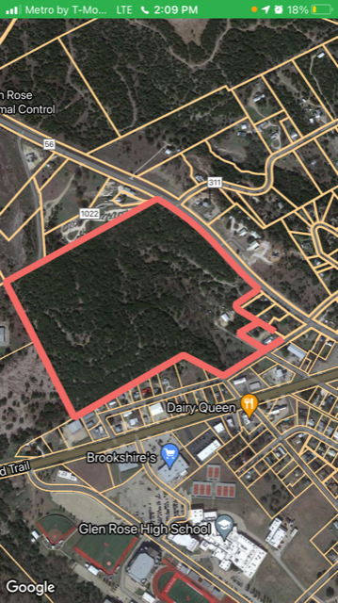
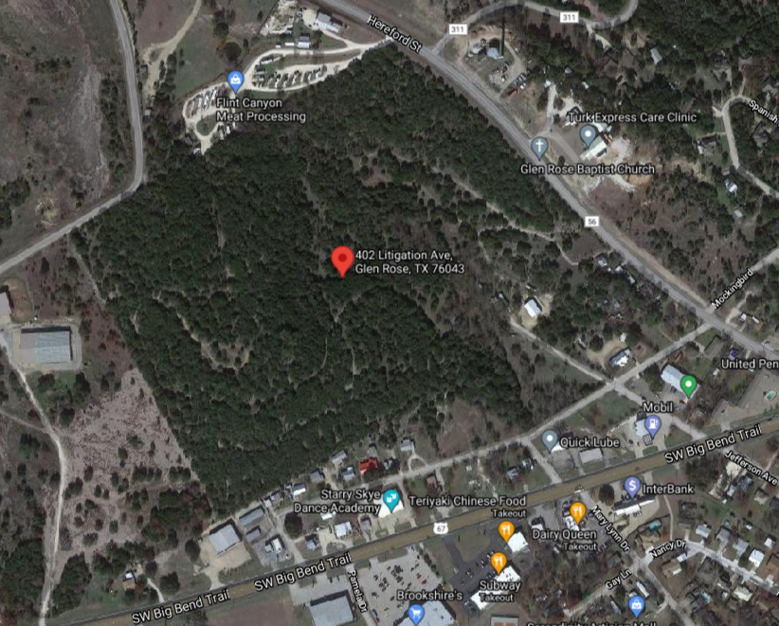
Owner: John Smith
Contact: Sally Brown
Phone: 625-555-4444
Email: _________@gmail.com
Site Address: 402 Litigation Avenue,
Glen Rose TX, 76043

Jurisdiction: Glen Rose
County: Somervell
City Population: 2,607
Size AC: 51.78
Price per Acre: $38,624.9
Size SF: 2,242,468
Price per SF: $0.89
Total Lots: 222 (7,000 sf)
Price per Lot: $70k
Zoning: Residential-1
Internal ID: (Allied Only)
Google Maps: Link

Important Notes

Conversation with Owner:
Per John, spoke with owner said that the property is not for sale but he would take $2M. Him and his sister own the piece and would let it go for $1M each.

Pricing:
Per John, $2M Firm

Other: This is a GREAT piece in Glen Rose, Tx is right in the middle of town up on a hill would be the best new sub-division in town. It has wonderful road frontage and access from 3 sides of the property.

Maps & Links

GIS (city, county, etc.): http://map.3cgeo.com/fist/fistMain.php?site=grpublic

Google Maps: Link

Google Earth: Link

Other helpful links (planning department, permit fees, etc.):
Somervell County Property Search: Link
Somervell Gis: Link

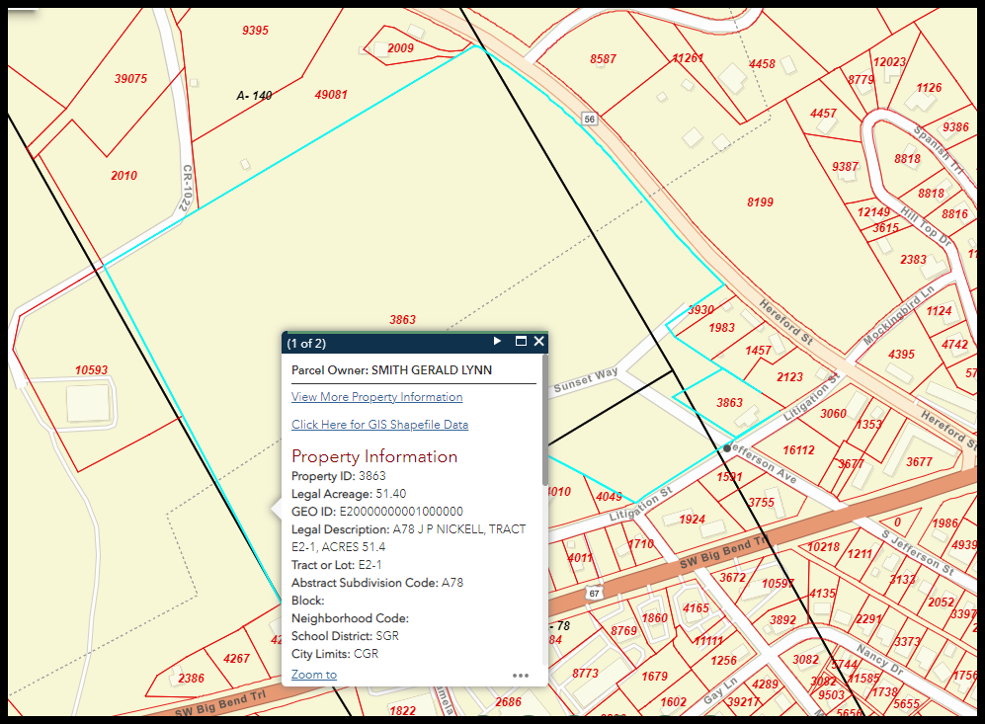
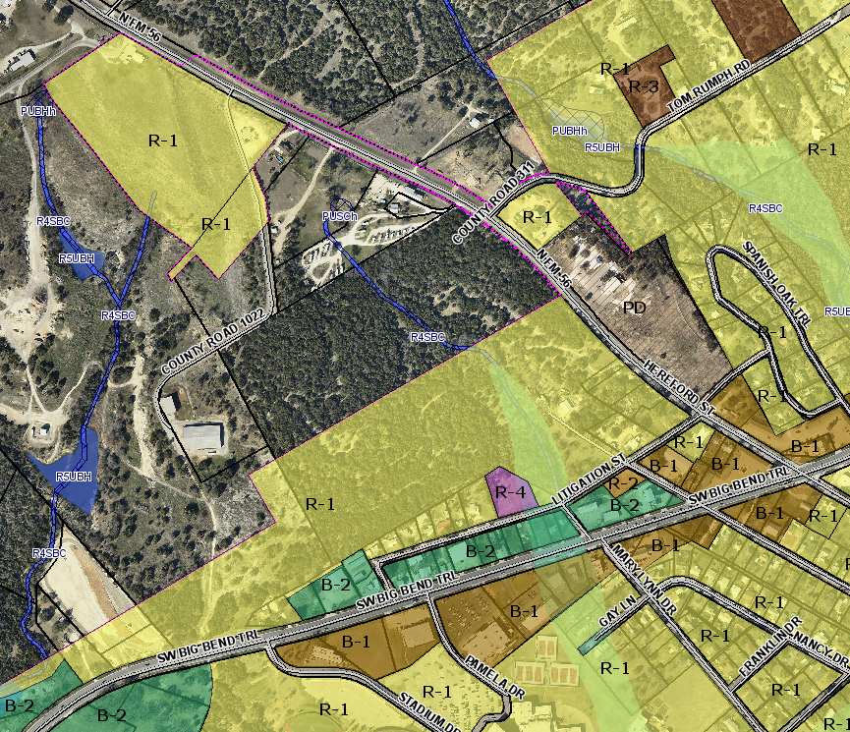

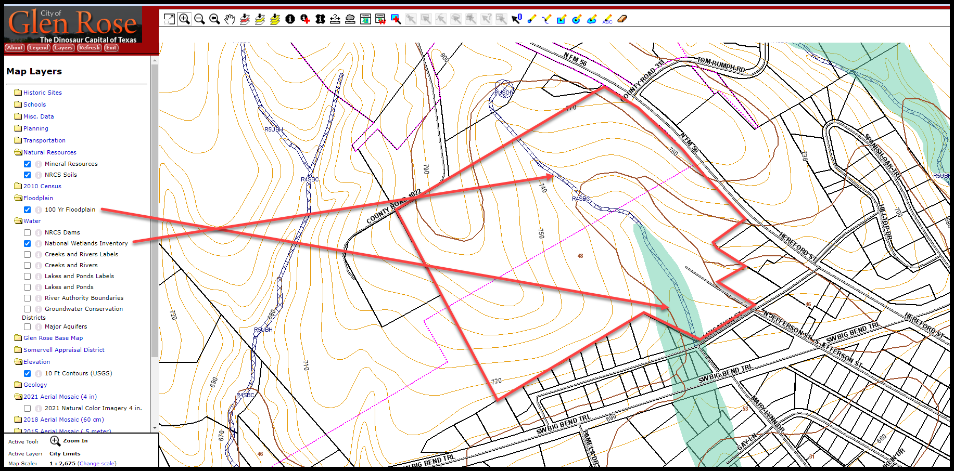

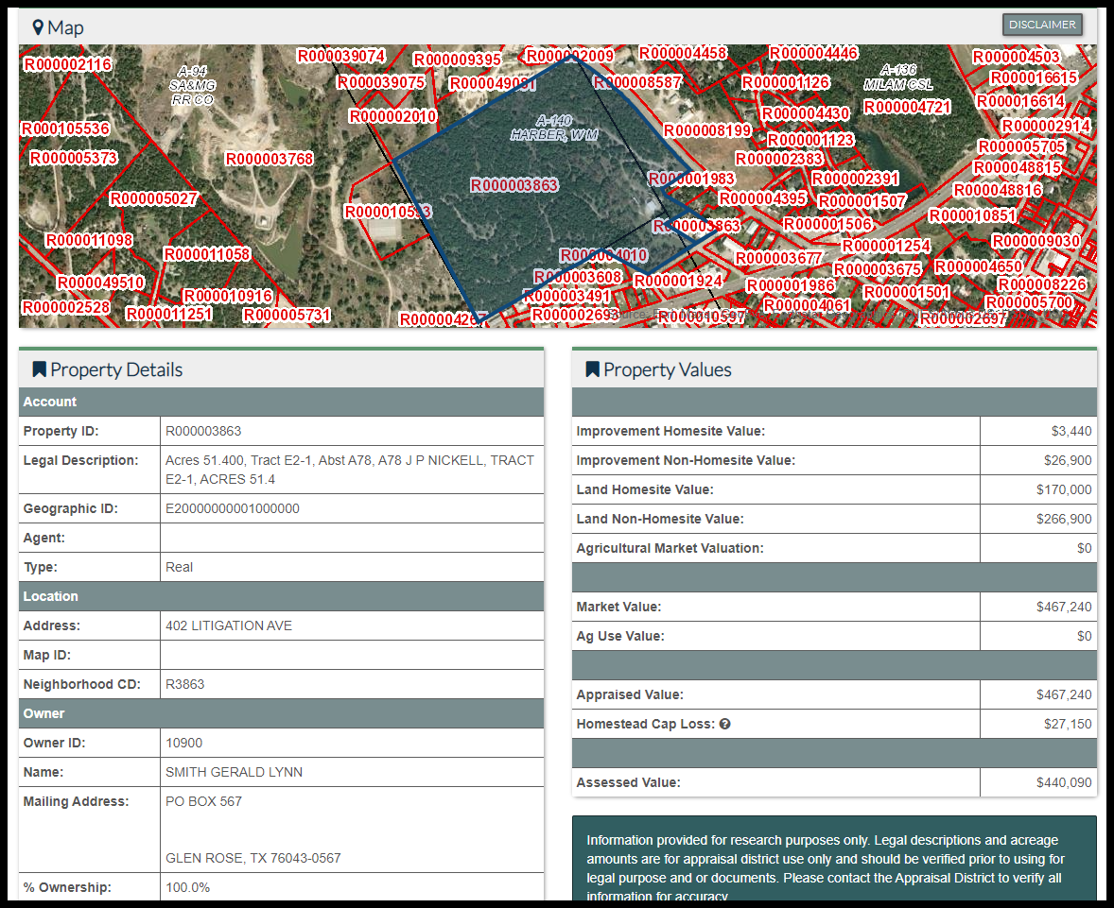

Residential Checklist

City of Glen Rose:
Building Official - Planner: Kyle Reeves (buildingofficial@glenrosetexas.org)
Public Works: Jim Holder - 254.396.5626 (jim.holder@glenrosetexas.org)
City Manager: Michael Leamons
City Engineer:

Existing Home:
Is there an existing home: Yes
Year: 1956
Size: 1,500 sf
Garage: Detached 2-car
Keep or Demo: Demo
If keeping, what is its estimated value once it’s on its own single lot:
Condition of home:
If Demo, see Other/Offsites below

Zoning:
Current Zoning (Single-Family, Multi-Family, Attached, Detached, Agriculture, etc.): Per John, Currently zoned R1 half of the property is in the city limits the other half will need to be annexed in (see map above).
Spoke to Kyle Reeves on 10/5/21 (JH):
Kyle says that the property is zoned R-1,
Minimum Lot size: 6,600 sf lots (60 x 110).
Setbacks: 25 ft (front & rear) & 7 ft (side)
Max Height: 2.5 stories
He said that the north portion would come in as the same and that annexation can run concurrently with LU as they are doing that on other projects in the city.

Annexed: Per Daniel, half the property is annexed but the other portion will need to be annexed in.
Spoke to Kyle Reeves on 10/5/21 (JH):
Kyle says that annexation is not an issue for the north portion of property.

Utilities:
Sewer (location, capacity issues, etc.): Per Daniel, sewer is in the road off of Litigation.
Per Jim Holder (Public Works) via email on 10/6/21 (JH):
I can help answer a couple of questions today, but I need to reach out to our civil engineer about sewer capacity for the development of that amount of property. There are existing sewer manholes at the intersections of Jefferson St./Litigation, and at Mary Lynn/Litigation. The sewer mains are 6" at both manholes, but neither of them extend East to West along the section of property facing Litigation. There are no sewer mains along Hwy 56 (Hereford St.).

Water (location, capacity issues, etc.): Per Daniel, city water is already on the property at the house there that he currently owns.
Per Jim Holder (Public Works) via email on 10/6/21 (JH):
Water will not be an issue. There is an existing 8" high pressure water main on the North side of Litigation, and a 10" along the East side of Hwy 56 (Hereford St.).

Storm (per jurisdiction, how is storm water dealt with):
Per Jim Holder (Public Works) via email on 10/6/21 (JH):
As for the drainage, I believe that there is a natural drainage area crossing the property. Drainage improvements will definitely be a huge concern for the development of this area. Within the last couple of years, the City invested in drainage improvements downstream of Litigation, to handle the existing flows. Any additional drainage will need to be studied.

Power (any foreseeable issues): Per Daniel, No.

Environmental:
Wetlands: Yes, there is some drainage that is showing up on Gis as Wetlands.
Overlays: No
Topography: See topo map.
Floodplain (FEMA - https://msc.fema.gov/portal/home):
Steep Slopes: Per Daniel, it has a little bit of slopes but not too bad.
Water rights, Gas rights, Etc.: NA

Other/Offsites:
Transportation (Street Improvements, Traffic Impact Fees, Intersections/Frontage, etc):
Spoke to Kyle Reeves on 10/5/21 (JH):
Kyle not aware of anything.

Utilities (pump stations, upgrade to water/sewer lines, water treatments plants, etc):
Spoke to Kyle Reeves on 10/5/21 (JH):
Kyle not sure. I have reached out to Jim Holden on if there is any capacity issue.

Demo (House – year built & size, barns, out buildings, etc): Yes

Home Comps (New Construction):
JH: Received Comps from John.
**See Valuation and Project Folder

Land Comps:
JH: Received Comps from John.
**See Valuation and Project Folder

School Info:
Please use this website: https://www.greatschools.org/
https://www.greatschools.org/texas/glen-rose/schools/

